**BBC Good Food**

* Easy to navigate bar with lots of user needs
* Plenty of recipes covering various preferences and needs – this helps users filter through, however is also not an ideal filter system as it could be an information overload for many users
* Updated website as seen with seasonal/holiday meals
* Heart warming image of hot cross buns, symbolises the home – gives users comfort of using the site with a sense of familiarity
* The website contains good use of semiotics with arrows on the drop down menu to show there is more information.
* Clear colour scheme with the pink highlighted sections standing out and quickly catching the eye
* Placement of elements around the screen are quite traditional and familiar which will allow for users who frequent websites familiar navigation

* Nice layout with sections either segmented off from one another with lines, spacing, borders or sizing.

The method is broken up into simple and clear steps with spacing in between each one to visibly show a new step.

The subheadings are clear in full caps and bold text.

Steps are simple and precise with the word ‘pan’ highlighted to link to another page.

Possible recommendation would be to link technical cooking words to definition pages for clearer instructions.

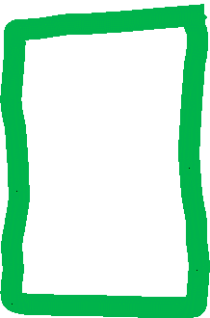

List of ingredients with each one having links to a description page for more information.

The links for the extra pages are clear with underlining and different colour text.



Video demonstrating how to create the dish just below the recipes name and above the ingredients/method.

Not very good positioning but can be made fullscreen.

**Yummly**

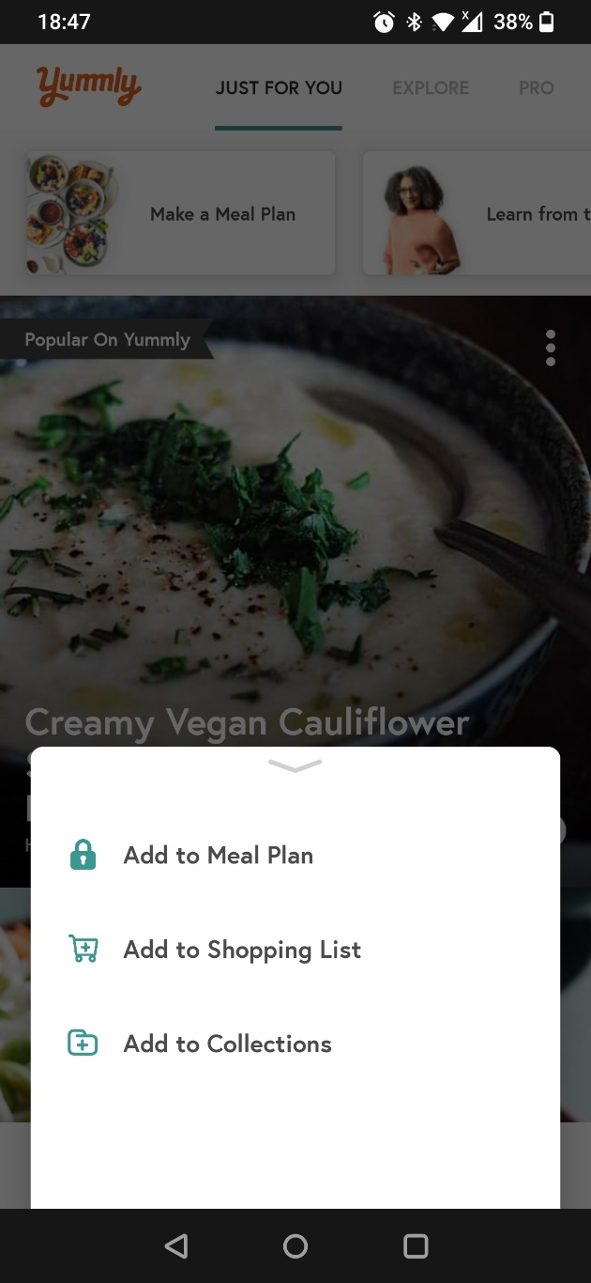

Tag in the top left of the image gives extra details to the recipe and indicates to the user this is a good recipe to try.

The image on screen takes up a big portion of the screen, however it clearly conveys the recipe outcome as well as the recipe title, which is all you need to intrigue a customer to click and find out more.

Pages with different goals, as shown with the underlined heading I am on the page dedicated to recipes targeted towards me.



The pop-up menu shows the options available for this recipe before clicking inside of it. The user can add it to their meal planner for the week, their current/always active shopping list or a collections page which works as a favourite page.

Symbols are okay but could possibly do with changing to become a little clearer without text.



Three bar in the top right symbolises there is more information.



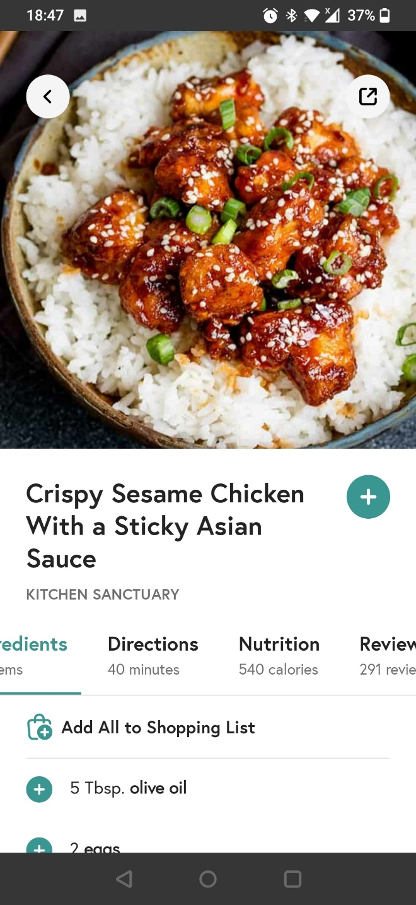

The recipe page is linked to the shopping list. Users can add individual ingredients or the whole recipe to their shopping list if needed.

Slide navigation for more pages on this one page. This covers a variety of pages from instructions to reviews.

Title and author title in case users want more from the author. This allows for a quick search.

Image taking a big proportion of the screen to appeal to audience and give an indication on how the recipe will look.

Symbols in both corners to share or go back – these are common symbols on multiple pages so users will familiar and not be confused when seeing them.



Button symbolises to a user they can interact with the recipe and add somewhere

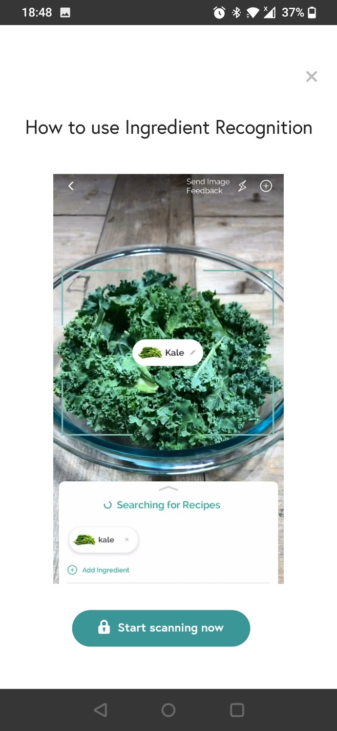

Camera recognition of ingredients. The camera will scan an ingredient and the app will make a guess on the ingredient giving a few results. You can then add this ingredient to your pantry or shopping list.

This is locked behind an account holder account.

Many of the features of Yummly need a user to have an account.